**Non parametric methods**

**Two Independent samples test**

**Mann-Whitney Test**

The Mann-Whitney test is an alternative for the [independent samples t-test](https://www.spss-tutorials.com/independent-samples-t-test/) when the assumptions required by the latter aren't met by the data. The most common scenario is testing a non-normally distributed outcome variable in a small sample (n < 25).  
The Mann-Whitney test is also known as the **Wilcoxon test** for independent samples -which shouldn't be confused with the [Wilcoxon signed-ranks test](https://www.spss-tutorials.com/spss-wilcoxon-signed-ranks-test-simple-example/) for relatedsamples. The data for this analysis contains three variables; score1, score2 and gender for 17 respondents. The research question is whether boys and girls have similar scores. For each score separately.

**Hypothesis**

Null hypothesis: The mean scores of boys and girls are equal.

Alternative hypothesis: The mean scores of boys are different from that of girls.

Histogram

Data visualization in terms of two split histograms is essential for inspecting how the data looks like.

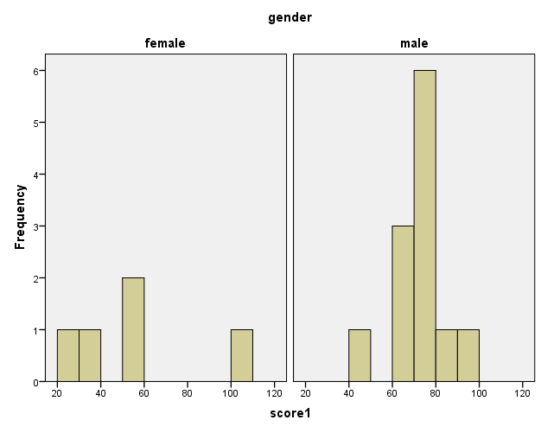

**The results look plausible**; we don't see any unusual values or patterns. Secondly, our outcome variables don't seem to be normally distributed and we've a total sample size of only n = 17. This argues against using a t-test for these data.  
Finally, by taking a good look at the split histograms, you can already see which scores are high in male as compared to female respondents. But even if they're rated perfectly similarly by large populations of boys and girls, we'll still see some differences in small samples. Large sample differences, however, are unlikely if the null hypothesis -equal population means- is really true. We'll now find out if our sample differences are large enough for refuting this hypothesis.

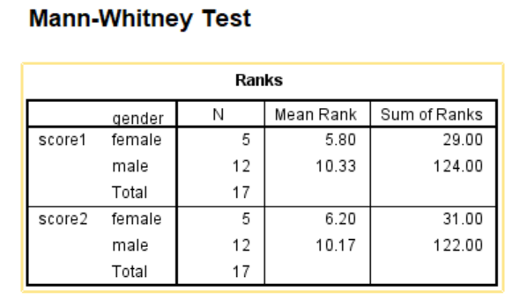

Our first score (“score1”) shows the largest difference in mean ranks between male and female respondents: males have highest scores. On the second score the pattern is similar.

**Output Significance Tests**

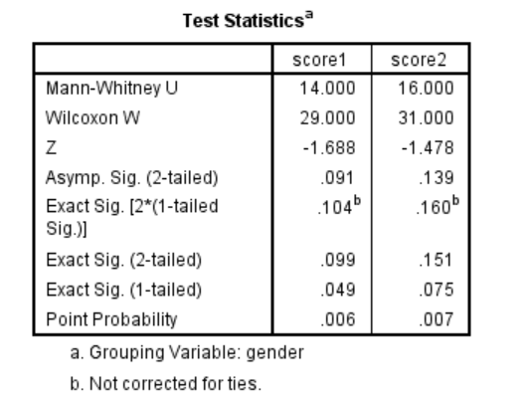

* Mann-Whitney U and Wilcoxon W, are the test statistics; they summarize the difference in mean rank numbers in a single number.
* **Exact Sig. (2-tailed)**: is the exact significance level corrected for ties.
* Second best is **Exact Sig. [2*(1-tailed Sig.)]**, the exact p-value but not corrected for ties.
* For larger sample sizes, our test statistics are roughly normally distributed. An approximate (or “**Asymptotic**”) p-value is based on the standard normal distribution. The z-score and p-value reported by SPSS are calculated without applying the necessary continuity correction, resulting in some (minor) inaccuracy.

**Conclusion**

Boys scored highly in score1 than girls (p-value = 0.049). Score2 didn't show a gender difference (p-value =0.10).The p-value of 0.049 indicates a probability of 49 in 1,000: if the populations of boys and girls score similarly, then we've a 49 in 1,000 chance of finding the large difference we observe in our sample*.*

**One sample** `**test**

**Shapiro-Wilk Test**

Shapiro-Wilk test first quantifies the similarity between the observed and normal distributions as a single number: it superimposes a normal curve over the observed distribution as shown below. It then computes which percentage of our sample overlaps with it: a **similarity percentage**. This test is used to prove or disprove the claim that the time taken by three athletes to finish a marathon in minutes are normally distributed. Sample size=242.

**Histogram**

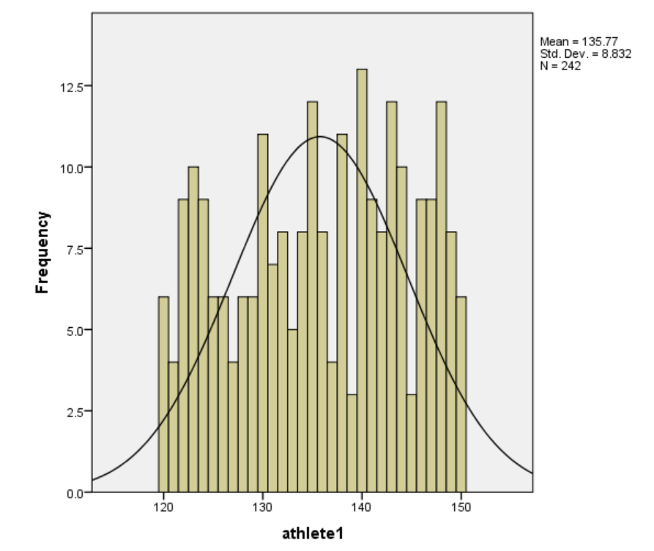

Finally, the Shapiro-Wilk test computes the probability of finding this observed or a smaller- similarity percentage. It does so under the assumption that the population distribution is exactly normal.

**Hypothesis**

Null: Time taken by athletes is normally distributed in a population.

Alternative: Time taken by athletes is not normally distributed in a population

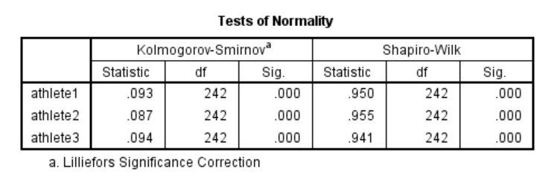

The ‘Sig.’ or p-value is the probability of finding the observed or a larger- deviation from normality in our sample if the distribution is exactly normal in our population. If time for athlete 1 is normally distributed in the population, there's a mere 0.000 -or 0%- chance of finding these sample data. These values are unlikely to have been sampled from a normal distribution. So the population distribution probably wasn't normal. We therefore reject this null hypothesis.

**Conclusion**:

Time taken by athlete 1, 2, and 3 are probably not normally distributed in the population.